Single-Molecule Electrical Detection
Xuefeng Guo*
College of Chemistry, Peking University, Beijing 100871, P. R. China
*guoxf@pku.edu.cn

A universal lithographic methodology for creating single-molecule devices based on carbon nanomaterials as point contacts has been developed. In this talk, I will detail our rational for our use of bioassay techniques by using molecular bridges with functional side groups capable of subsequent biocompatible assembly. We have tested this approach in chemical/biological systems, including DNA hybridization, aptamer-protein interaction, host-guest interaction, hydrogen-bond dynamics and basic chemical reactions. Because it is constructed from a single molecule, each device can monitor individual binding events in real time. This methodology demonstrates a connection between electrical conduction and chemistry/biology that offers a glimpse into the future of integrated multifunctional sensors and devices.
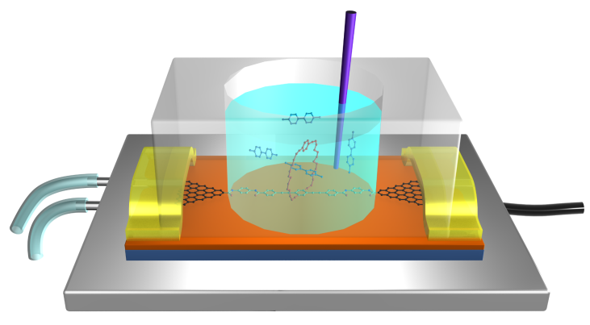
Figure 1. Schematic of single-molecule detection using molecular electronic devices.

References：
[1] C. Jia, X. Guo, et al., Science 352, 1443 (2016).
[2] D. Xiang, X, Wang, C. Jia, T. Lee, X. Guo, Chem. Rev. 116, 4318 (2016).
[3] C. Jia, B. Ma, N. Xin, X. Guo, Acc. Chem. Res. 48, 2565 (2015).
[4] X. Guo, C. Nuckolls, et al., Nat. Nanotech. 3, 163 (2008).
[5] X. Guo, Adv. Mater. 25, 3397 (2013).
[6] A. Feldmen, X. Guo, C. Nuckolls, et al., Acc. Chem. Res. 41, 1731 (2008).
[7] X. Guo, P. Kim, C. Nuckolls, et al., Science 311, 356 (2006).
[8] Y. Cao, X. Guo, et al., Angew. Chem. Int. Ed. 51, 12228 (2012).
[9] J. Wang, X. Guo, et al., Angew. Chem. Int. Ed. 53, 5038 (2014).
[10] G. He, J. Li, C. Qi, X. Guo, Angew. Chem. Int. Ed. 55, 9036 (2016).

Biography
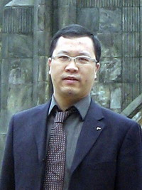
Xuefeng Guo received his Ph.D. degree in Organic Chemistry in 2004 from the Institute of Chemistry, Chinese Academy of Science, Beijing. In 2006, he was awarded the National Top 100 Excellent Ph. D. Thesis Award in China. From 2004 to 2007, he was a joint postdoctoral scientist at the Columbia University Nanocenter. He joined the faculty as a professor under “Peking 100-Talent” Program at College of Chemistry and Molecular Engineering, Peking University in January 2008. In 2012, he won the National Science Fund for Distinguished Young Scholars in China. His research interests are focused on single-molecule devices and device physics, flexible/organic electronics, single-molecule detection and dynamics, etc..

